My MIPS_16 DOCUMENT
Author: Fan ZhenYa, fzywork@163.com 0:33:34, Feb 16, 2012

Overview

Technical brief:
1. 16-bit data width
2. classic 5-stage static pipeline, 1 branch delay slot, theoretical CPI is 1.0
3. pipeline is able to detect and prevent RAW hazards, no forwarding logic
4. 8 general purpose register (reg 0 is special, according to mips architecture)
5. up to now supports 13 instructions, see ./doc/instruction_set.txt for details
6. Maximum clk Frequency: 82.688MHz on Xilinx 3s1000fg320-5 device (XST).

Architecture

Implementation

IF_stage:
PC, and a asynchronized instruction memory(a ROM for simulation). Instruction memory further can be an I-cache or an external instruction memory interface.

ID_stage:
Central control logic and Register read
Truth table of Central Control Logic:
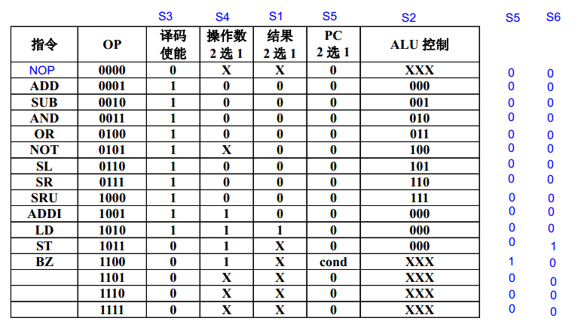

EX_stage:
ALU

MEM_stage:
A ram for now, further can be a D-cache or an external memory interface.

WB_stage:
Write back stage

Register File:
a 8-entry 16-bit register file, with 1 synchronized write port and 2 synchronized read port. For Register 0, read data from it will always be 0, and write operations will also be discarded.

Hazard Detection Unit:
Data Hazard detection. if there is a RAW hazard, it will stall the pipeline.
Method: It compare the source register of the instruction in ID_stage and it's previous 3 instructions' destination register. If the source register is equal to any of the three destination regs and not equals to zero, the Hazard Detection Unit will assert pipeline_stall signal. That signal will freeze the IF & ID stage, and insert bubbles into EX stage. When the hazard instruction was flushed out of the pipeline, pipeline_stall signal will be canceled.

Testbenches:
Every module in this project has its complete testbench and corresponding modelsim simulation scripts, located in ./bench/<modelname>.

Software tools

FPGA Synthesis & Implement tool:
Xilinx ISE, work directory: ./backend/Xilinx
Synthesis report:

Device utilization summary:
---------------------------
Selected Device : 3s1000fg320-5
Number of Slices: 456 out of 7680 5%
Number of Slice Flip Flops: 290 out of 15360 1%
Number of 4 input LUTs: 883 out of 15360 5%
Number used as logic: 627
Number used as RAMs: 256
Number of IOs: 10
Number of bonded IOBs: 10 out of 221 4%
Number of GCLKs: 1 out of 8 12%

Timing Summary:
---------------
Speed Grade: -5

Minimum period: 12.094ns (Maximum Frequency: 82.688MHz)
Minimum input arrival time before clock: 6.115ns
Maximum output required time after clock: 6.678ns
Maximum combinational path delay: No path found

RTL Simulation tool:
Modelsim SE 10.0a, work directory: ./sim

Assembler:
A assembler implemented by JAVA, Java version: 1.6.0_30. In directory: ./sw
Useage:
java mips_16_assembler [Options]
Options:
<source_code_path> <dest_path>:
Assemble source code to dest. For exaple .\bin\test1.asm .\bin\test1.prog
<source_code_path>:
Assemble source code to dest file a.prog
-h(or --help):
Show this help

Sample programs

Test1:
Purpose: test basic instrctions, and RAW hazard protection
Source code: (\bench\mips_16_core_top\test1.asm)
L1: ADDI R1,R0,8
ADDI R2,R1,8
ADDI R3,R2,8
ADD R4,R2,R3
ST R4,R1,2
LD R5,R1,2
SUB R6,R4,R5
BZ R6,L1
ADDI R7,R7,1
Modelsim simulation result:
# ***************************
# mips_16 core test
# ***************************
#
# rom load successfully
#
# running test1
#
# current pc: 0 ,instruction: 9208
# current pc: 1 ,instruction: 9448
# current pc: 2 ,instruction: 9688
# current pc: 3 ,instruction: 1898
# current pc: 4 ,instruction: b842
# current pc: 5 ,instruction: aa42
# current pc: 6 ,instruction: 2d28
# current pc: 7 ,instruction: c1b8
# current pc: 8 ,instruction: 9fc1
# current pc: 0 ,instruction: 9208
# current pc: 1 ,instruction: 9448
# current pc: 2 ,instruction: 9688
# current pc: 3 ,instruction: 1898
# current pc: 4 ,instruction: b842
# current pc: 5 ,instruction: aa42
# current pc: 6 ,instruction: 2d28
# current pc: 7 ,instruction: c1b8
# current pc: 8 ,instruction: 9fc1
# current pc: 0 ,instruction: 9208
# current pc: 1 ,instruction: 9448
…….
# display_all_regs:
# ------------------------------
# R0 R1 R2 R3 R4 R5 R6 R7
# 0 8 16 24 40 40 0 3
# ------------------------------
# ram[10] = 40

Test2:
Purpose: Multiply R3=R1*R2 using add and shift instructions
Source code: (\bench\mips_16_core_top\test2.asm)
Modelsim simulation result:
# ***************************
# mips_16 core test
# ***************************
#
# rom load successfully
#
# running test2
#
# multiply R3=R1*R2
#
# display_all_regs:
# ------------------------------
# R0 R1 R2 R3 R4 R5 R6 R7
# 0 0 0 0 0 0 0 0
# ------------------------------
# running test2
#
# current pc: 0 ,instruction: 921c
# current pc: 1 ,instruction: 9411
# current pc: 2 ,instruction: 9c01
# current pc: 3 ,instruction: 9e00
# current pc: 4 ,instruction: 9a10
# current pc: 5 ,instruction: 9fc1
# current pc : 6
# display_all_regs:
# ------------------------------
# R0 R1 R2 R3 R4 R5 R6 R7
# 0 28 17 0 0 0 0 0
# ------------------------------
# current pc: 6 ,instruction: 3990
# current pc: 7 ,instruction: c102
# current pc: 8 ,instruction: 0000
# current pc: 9 ,instruction: 16c8
# current pc: 10 ,instruction: 6270
# current pc: 11 ,instruction: 84b0
# current pc: 12 ,instruction: 2978
# current pc: 13 ,instruction: c103
# current pc: 14 ,instruction: 0000
# current pc: 15 ,instruction: c035
# current pc: 16 ,instruction: 0000
# current pc: 5 ,instruction: 9fc1
# current pc : 6
# display_all_regs:
# ------------------------------
# R0 R1 R2 R3 R4 R5 R6 R7
# 0 56 8 28 15 16 1 1
# ------------------------------
# current pc: 6 ,instruction: 3990
# current pc: 7 ,instruction: c102
# current pc: 8 ,instruction: 0000
# current pc: 10 ,instruction: 6270
# current pc: 11 ,instruction: 84b0
……..
# current pc: 14 ,instruction: 0000
# current pc: 15 ,instruction: c035
# current pc: 16 ,instruction: 0000
# current pc: 5 ,instruction: 9fc1
# current pc : 6
# display_all_regs:
# ------------------------------
# R0 R1 R2 R3 R4 R5 R6 R7
# 0 0 0 476 2 16 1 14
# ------------------------------
# current pc: 6 ,instruction: 3990
# current pc: 7 ,instruction: c102
# current pc: 8 ,instruction: 0000
# current pc: 10 ,instruction: 6270
# current pc: 11 ,instruction: 84b0
# current pc: 12 ,instruction: 2978
# current pc: 13 ,instruction: c103
# current pc: 14 ,instruction: 0000
# current pc: 15 ,instruction: c035
# current pc: 16 ,instruction: 0000
# current pc: 5 ,instruction: 9fc1
# current pc : 6
# display_all_regs:
# ------------------------------
# R0 R1 R2 R3 R4 R5 R6 R7
# 0 0 0 476 1 16 1 15
# ------------------------------
# current pc: 6 ,instruction: 3990
# current pc: 7 ,instruction: c102
# current pc: 8 ,instruction: 0000
# current pc: 10 ,instruction: 6270
# current pc: 11 ,instruction: 84b0
# current pc: 12 ,instruction: 2978
# current pc: 13 ,instruction: c103
# current pc: 14 ,instruction: 0000
# current pc: 17 ,instruction: c03f
# current pc: 18 ,instruction: 0000
# current pc: 17 ,instruction: c03f
# current pc: 18 ,instruction: 0000
…….
# current pc: 17 ,instruction: c03f
# current pc: 18 ,instruction: 0000
# display_all_regs:
# ------------------------------
# R0 R1 R2 R3 R4 R5 R6 R7
# 0 0 0 476 0 16 1 16
# ------------------------------

Reference
胡伟武，计算机体系结构，清华大学出版社，2011

